
Setup View – Browse Skillsets Perspective
Link Schedules to Skillsets

This reference guide provides an overview of the process for Linking Schedules to Skillsets within StaffReady. The following process steps and instructional information are provided within this document:

- Associate Job Descriptions to Grades
- Remove Job Descriptions from Grades

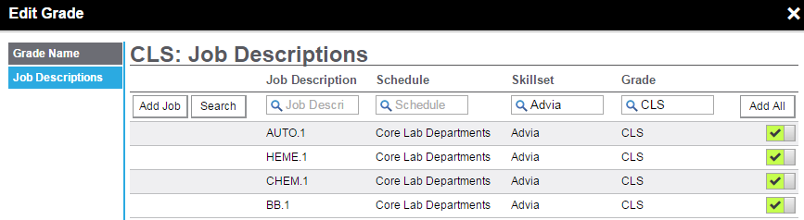

1 | Associate Job Descriptions to Grades
This requires the Schedule Module. Associating a Schedule to a Grade ensures that an employee will cease being scheduled shift assignments associated to a Job Description if they become overdue or fail a competency assessment..

Associate Job Descriptions to Grades
1. Select Browse Skillsets perspective.  2. Select a Skillset. | 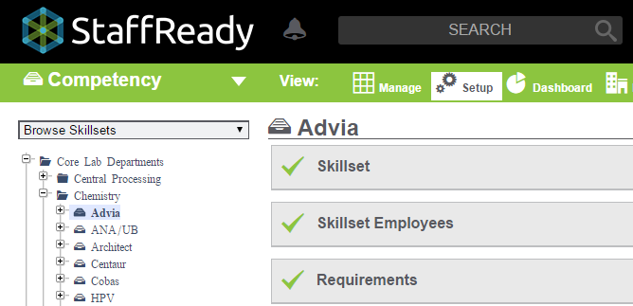
3. Open Grades colorbar.  4. Click jobs. | 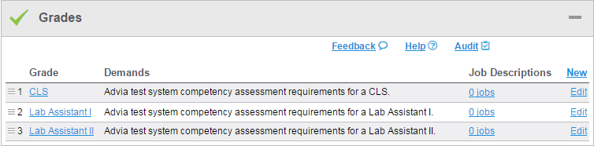
6. Click Add Job. | 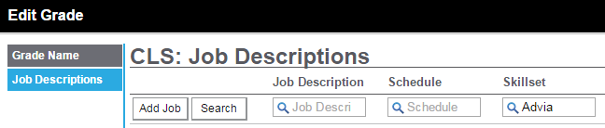
7. Enter Job Descriptions and/or Schedules to search.  8. Click Search. | 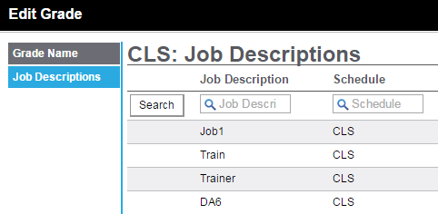
9. Click to associate a Job Description to the Grade.  10. Click Add All to associate every Job Description in the list to the Grade. | 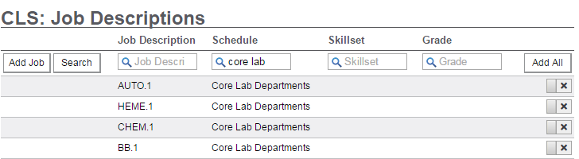

2 | Remove Job Descriptions from Grades

Remove Job Descriptions from Grades
1. Select Browse Skillsets perspective.

2. Select a Skillset.

3. Open Grades colorbar.  4. Click jobs. | 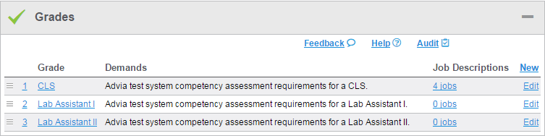
6. Click to disassociate a Job Description from a Grade.

