
Setup View – Browse Skillsets Perspective
Skillset Grades

This reference guide provides an overview of the setup process for Skillset Grades within StaffReady. The following process steps and instructional information are provided within this document:

- Add New Grade
- Edit Grade
- Reorder Grades
- Associate Requirements to Grades
- Remove Requirements from Grades

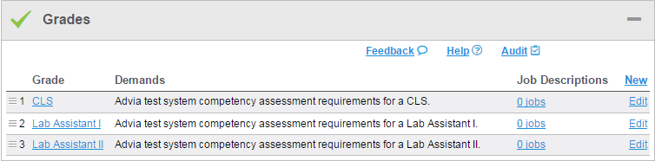

1 | Add New Grade

Add New Grade
1. Select Browse Skillsets perspective.  2. Select a Skillset. | 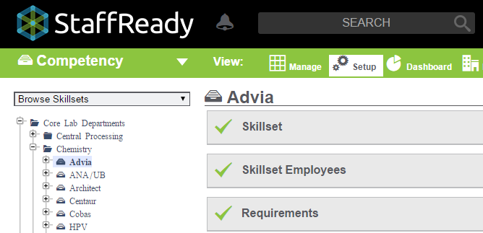
3. Open Grades colorbar.  4. Click New. | 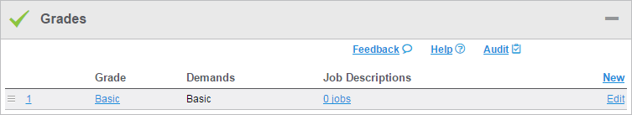
5. Enter Grade name.  6. Enter Grade Description.  *Should be changed from Demands to Description before launch  7. Click Save Changes. | 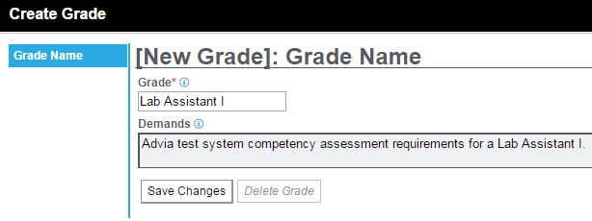

2 | Edit Grade

Edit Grade
1. Select Browse Skillsets perspective.

2. Select a Skillset.

3. Open Grades colorbar.  4. Click Edit. | 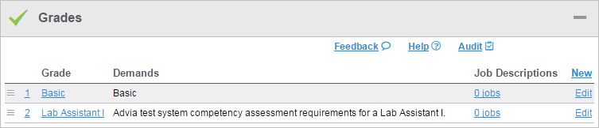
5. Edit Grade name.  6. Edit Grade Description.  *Should be changed from Demands to Description before launch  7. Click Save Changes. | 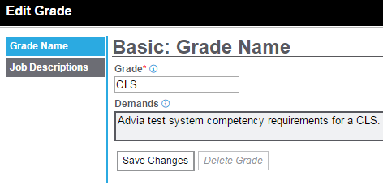

3 | Reorder Grades

Reorder Grades
1. Select Browse Skillsets perspective.

2. Select a Skillset.

3. Open Grades colorbar.  4. Click and grab . | 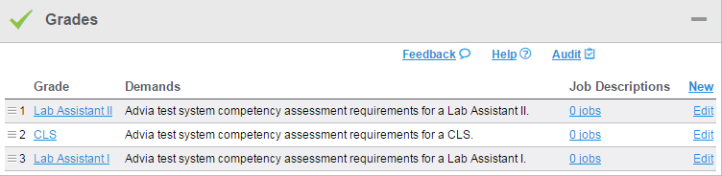
5. Drag Grade. | 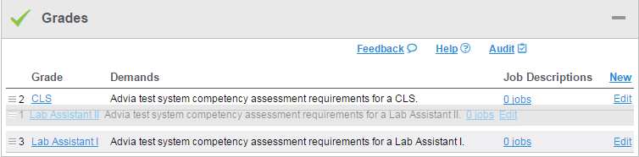
6. Drop Grade.

4 | Associate Requirements to Grades

Associate Requirements to Grades
1. Select Browse Skillsets perspective.

2. Select a Skillset.

3. Open Requirements colorbar.  4. Click Slider. | 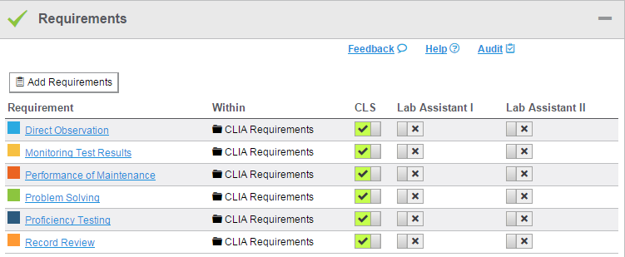

5 | Remove Requirements from Grades

Remove Requirements from Grades
1. Select Browse Skillsets perspective.

2. Select a Skillset.

3. Open Requirements colorbar.  4. Click Slider. | 